Working with Elastic Load Balancing

1. Create WEB Servers

- creating two ec2 instances amazon linux image, security group, removed ssh and http allowed.

2. Connecting to web servers with public dns

ec2-52-27-66-138.us-west-2.compute.amazonaws.com

ec2-35-161-174-46.us-west-2.compute.amazonaws.com

3.Creating a load balancer

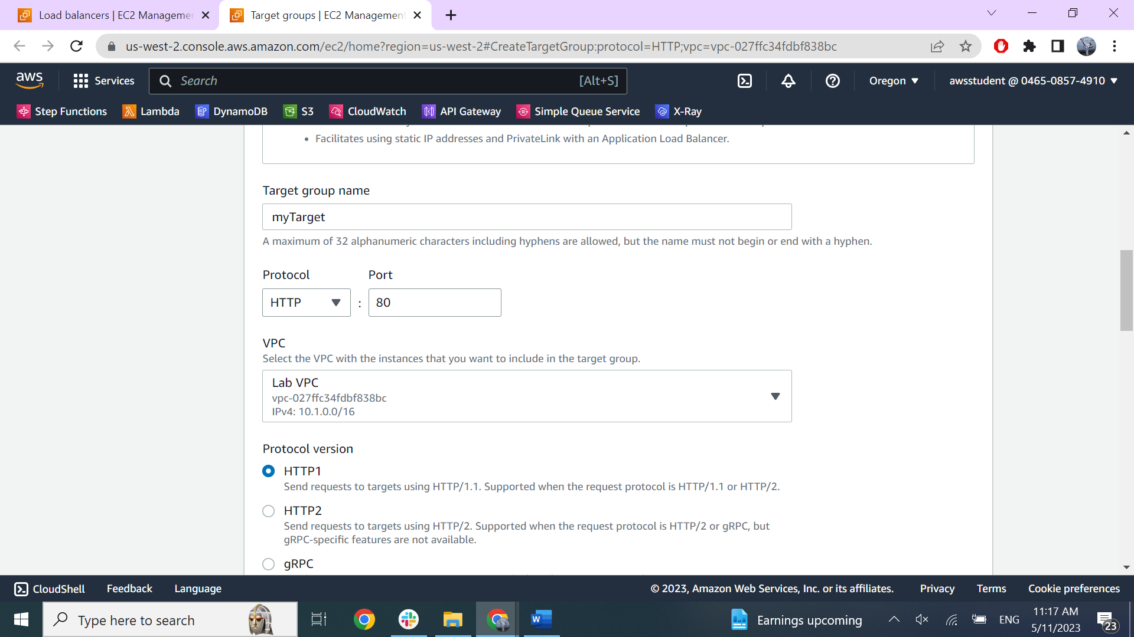

ELB-1216469553.us-west-2.elb.amazonaws.com

- copy past the dns neme in browser and see result.

- target group to see if the instances are healthy

4.See metrics in CloudWhatch -> Metrics -> All metrics -> ApplicationELB

